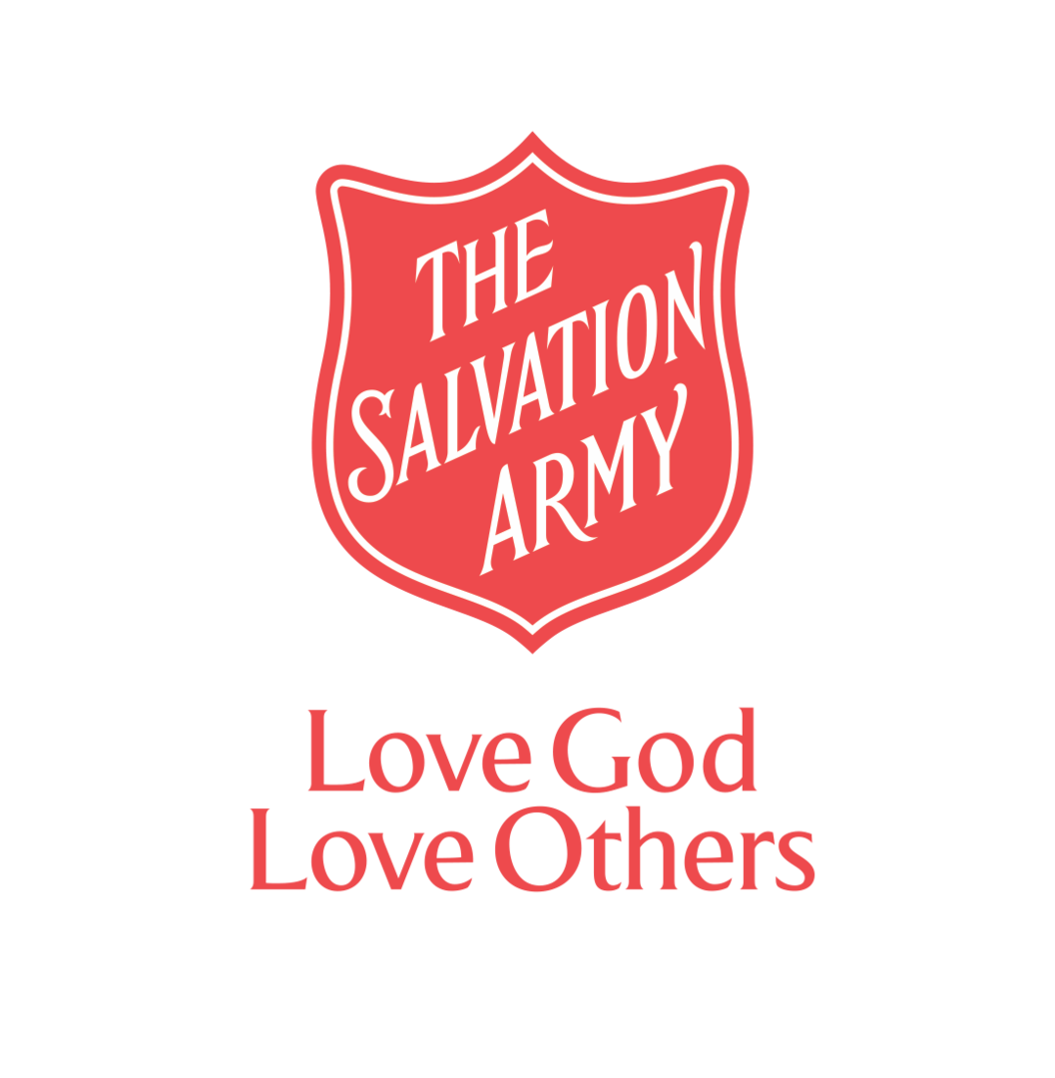
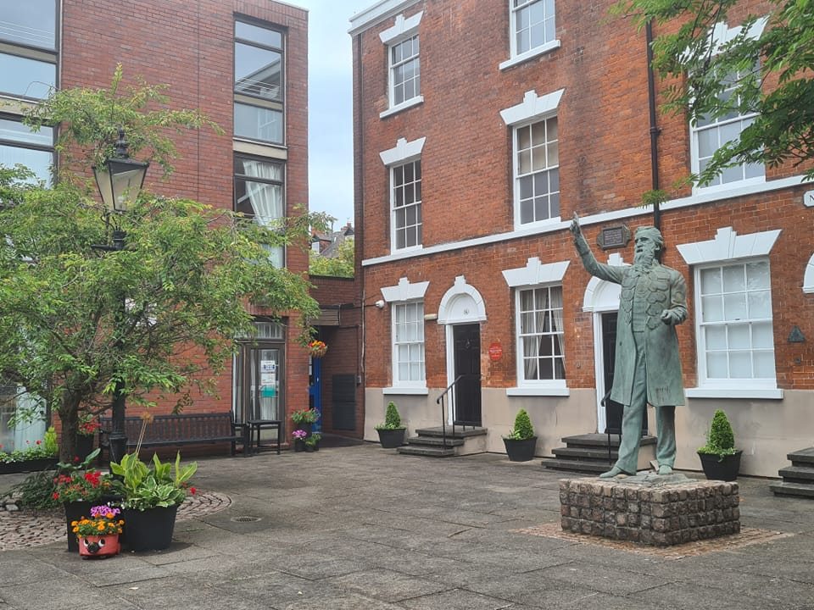
In Tune with Notintone
October 2023

SNEINTON’S FAMOUS SON PREACHER

A Methodist Revivalist Preacher

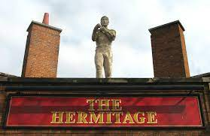  The above headline could be written about William Booth and maybe that’s what you are expecting. But it’s not. Let me introduce you to William Thompson (1811-1880) AKA Bendigo, one of the most famous bare-knuckle boxing champions. What isn’t so well-known about Bendigo is that after his fighting career had ended, he got saved and became a preacher.  We are pleased to announce that we are joining with the Bendigo Heritage Society and hosting a Bendigo Exhibition from Monday 16th October to Friday 1st December.  Why not come and learn about Bendigo: His Fights and Faith?  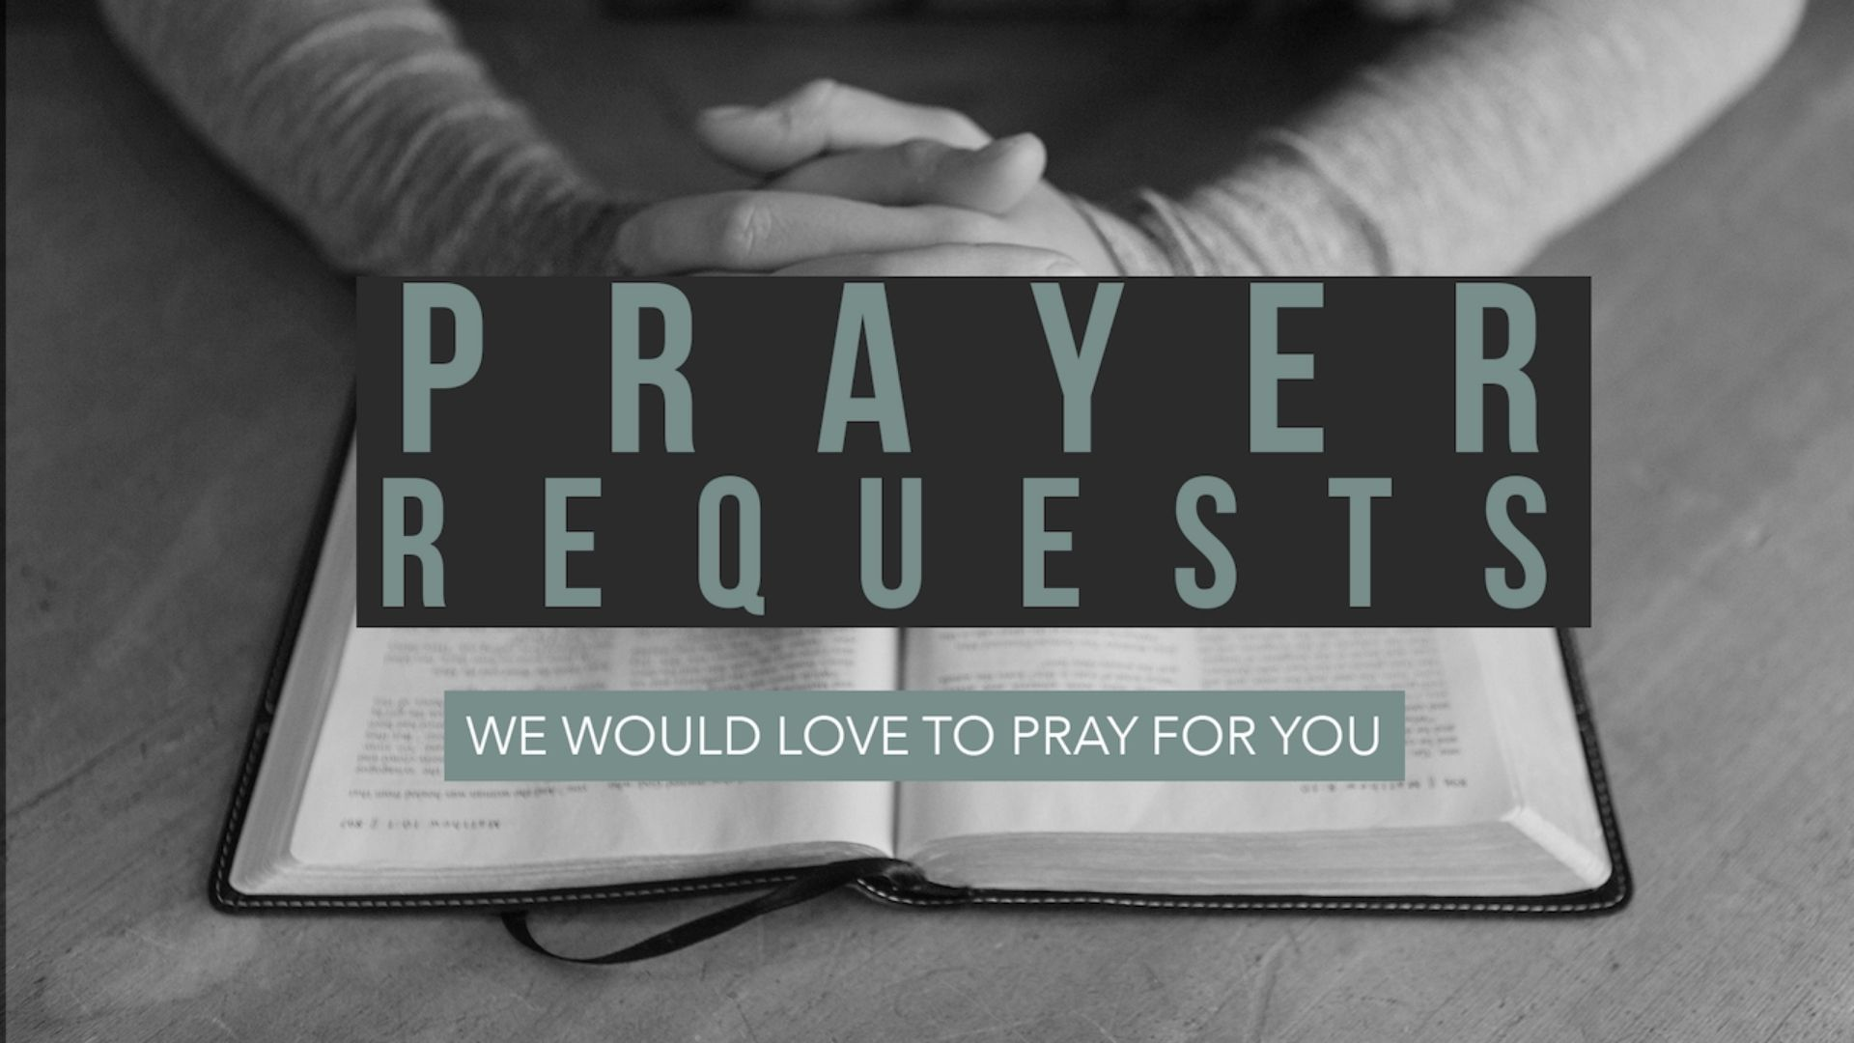  Living On a Prayer  We begin every week with Prayer for our Community. Please share any Prayer Requests you have with us and we will include them in our weekly Prayer meeting on Mondays at 9am, |  | COURTYARD CHAT  A new weekly Bible Study group  The Courtyard at Notintone Place is always well maintained, and we are so grateful to Paul and ‘Miners’ for the many hours they spend keeping it looking beautiful.  It offers a haven of peace, solitude, refreshment and reflection. 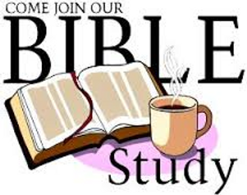  More spiritual reflection and refreshment will be available as we are launching a weekly Bible Study group on Friday 13th October from 2.30pm to 3.30pm.This will be held inside the Centre and all are welcome.
Contact: Community Mission Manager, Ian Young
Email: Ian.Young@salvationarmy.org.uk
Tel: 07587348459
Facebook: www.facebook.com/WBoothCentreSneinton
The Salvation Army, William Booth Memorial Complex, 14 Notintone Place, Sneinton, Nottingham. NG2 4QG

