A warm welcome as we gather as the family of God today, especially if you are not normally with us on a Sunday. May we all feel the welcome of God and each other.
Sunday 1st August 2021

August holiday edition
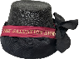
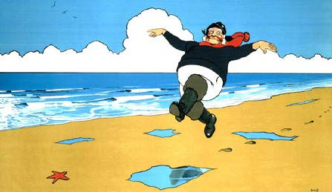

We meet at The Salvation Army Hall Sunday 10.30 am.

Also Sunday worship is live streamed from 10.15am on the Ramsgate Salvation Army YouTube Channel

The link for this is on the Ramsgate webpage
www.salvationarmy.org.uk/ramsgate
What’s happening at Ramsgate Salvation Army?

Sunday 1st 10.30 am WORSHIP at Salvation Army Hall

There is a full day of activities on Fortress Radio. https://www.fortressradio.online/listen-now.html

And don’t forget Songs of Praise Sunday at 13.15pm
Maggie is available with the constant prayer line where you can call or text for prayer. You can contact her on 07840 753 603

After Sunday the hall is closed – no activities will be taking place until Monday 16th August.
Sunday 8th August - you may want to join other Salvation Army corps on-line. Suggestions are Hendon, Chatham and Regent Hall.
Sunday 15th August. We have been invited by the Mayor of Ramsgate to represent the Corps at a Thanks Event at Charlotte Square at 11am. This will be a great opportunity to witness to our faith and work with others who have served the community over the last year.
Birthdays
The flowers this week
Our creator
Gay Boyden 01-Aug
Leanne Gomm 01-Aug
Melanie Goldfinch 04-Aug
Matthew Pearce 06-Aug
Mike Pearce 08-Aug
Claire Harden 13-Aug
Sandra Miles 13-Aug
Kate Barrett 17-Aug
Daphne Lee 20-Aug
John Horn 27-Aug
Patricia Turner 30-Aug

Prayers please for
Debbie following her recent hip operation. Debbie is now recovering at home
Grant, likewise, recovering at home following his operation this week.
Continued prayers for Rita, sister of Anna, Jean Mayton, Chris, a friend of Gay, Sam, step mum to Hollie, Grant and Al and David and John McCairn all waiting for medical treatment. For Archie, Lisa and Scott. For Paul and Sue Taylor. For Tara and for Angela and Jean S who are all due tests and examinations and await results. For all those suffering from Long Covid – which include some in our church family.
For all of our young people as they continue their summer holidays – and those too who are able to take holiday this summer. May they find rest and restoration.

Blessings for the Summer

Take time to claim your strength; this is a gift from God.

Take time to have fun; it is God’s way of teaching you your strengths.

Take time to grow yourself; only you can grow you.

Take time to trust yourself; God trusts you.

Take time to be self-reliant; it is better than being dependent.

Take time to share with others; they will bless you and you will bless them.

Take time to have hope; you are a child of God.

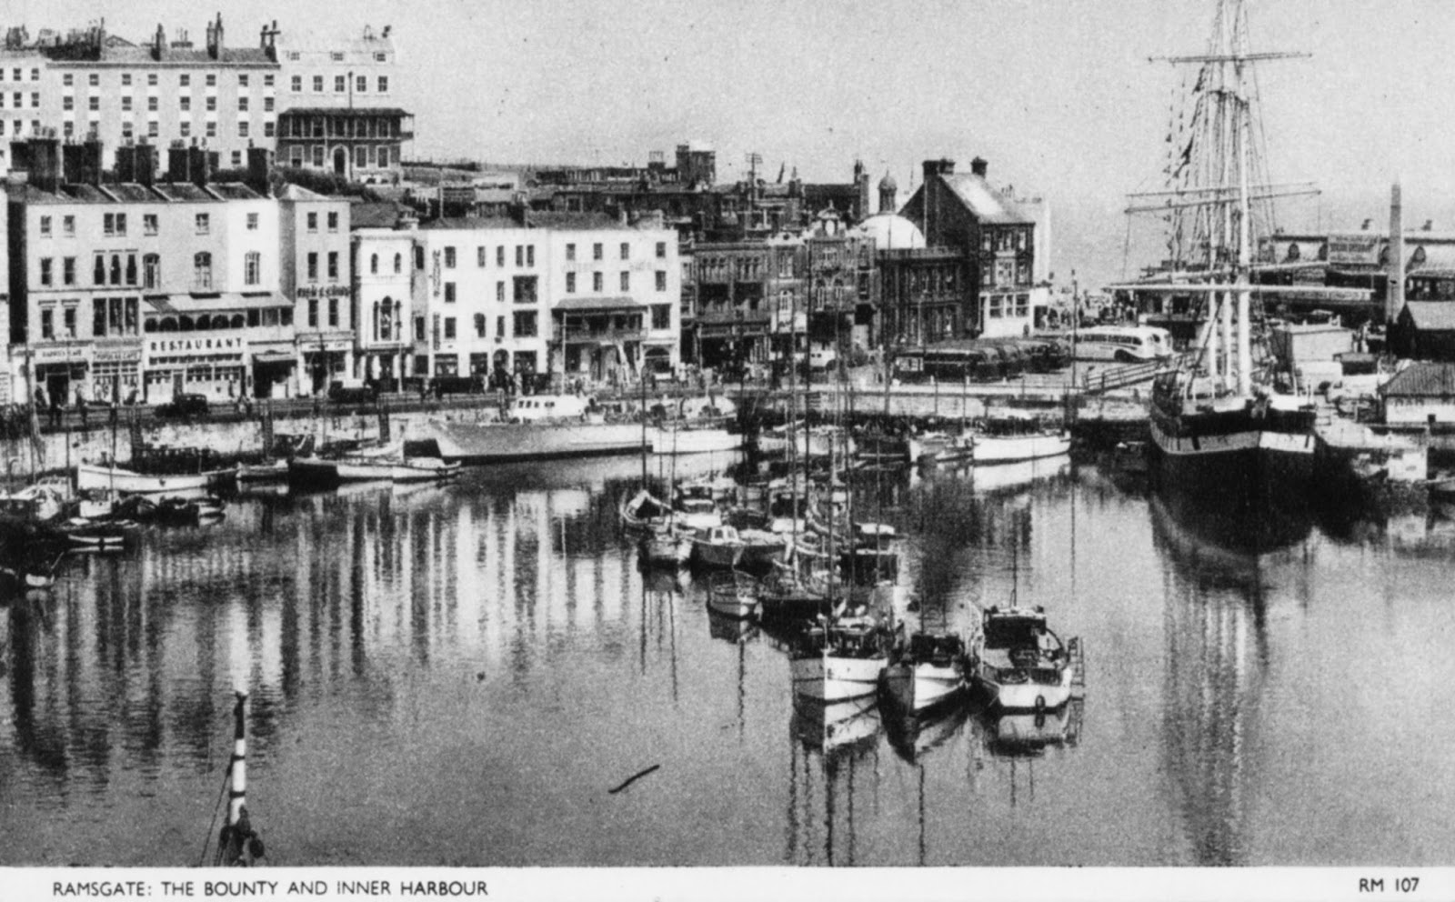

Prayer for the summer break

Lord, what about you and me? I don’t want to forget you just because I’m away from my normal routine.

Keep close to me, Lord, and remind me that my relationship with you should never take a break.
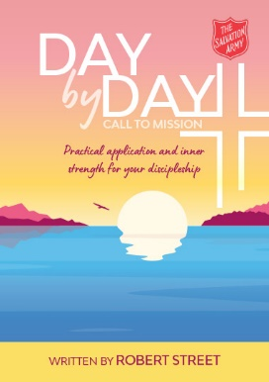

In with this newsletter you will have a copy of Day by Day. Written by Robert Street, it is a practical tool for us each to understand how we fit into God’s mission for the Salvation Army – and especially – how we might respond to the General’s call to mission.
The Salvation Army. 167 High Street Ramsgate Kent CT11 9TT
Corps Leaders Carl Whitewood 07900497326 Heather Whitewood 07747 004950
Carl.whitewood@salvationarmy.org.uk Heatherwhitewood@salvationarmy.org.uk
www.salvationarmy.org.uk/ramsgate
Shine on Me
As the sun rises, Lord,
Let your light shine on me.
Destroy the darkness about me,
Scatter the darkness before me,
Disperse the darkness behind me,
Dispel the darkness within me.
Let your light shine on me.
As the sun rises, Lord,
Let your light shine on me.
The warmth of your Presence,
The brightness of your love,
The radiance of your joy,
The shining of your hope.
Let your light shine on me.
As the sun rises, Lord,
Let your light shine on me.
Your light to guide,
Your light to lead,
Your light to direct,
Your light to brighten.
Let your light shine on me.

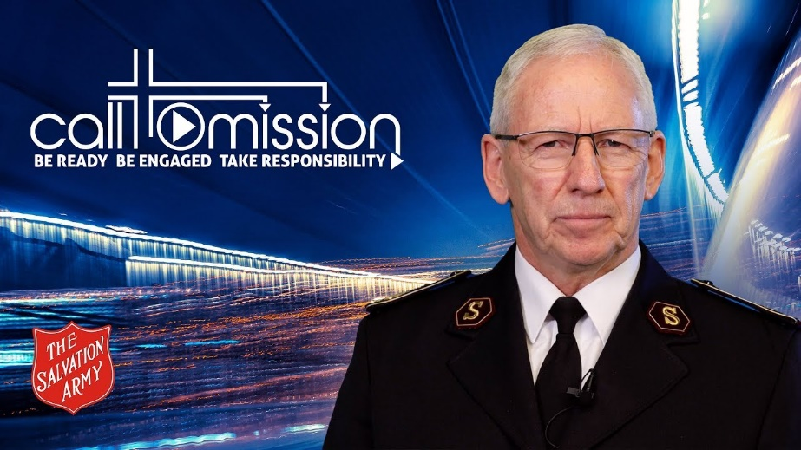

A call is only real when it is acted upon – when we have received it and then responded. As your General, I have made a commitment to listen to the promptings of the Holy Spirit when discerning God’s will and purpose for The Salvation Army in the coming years. And I will affirm my listening and revealed discernment by testing it with others, while also seeking God’s confirmation through personal prayer and the reading of the Word.
This call which God has placed on my heart is not only a call to me. It is a call for the whole Salvation Army. It needs to rest with and be responded to by every officer, soldier, adherent and junior soldier; as well as every employee and volunteer.
Everything we do should fulfil the sacred mission that God has given his Salvation Army. We know there are countless numbers of people in need of salvation, but even if there is only one more soul in need of it, we still have a duty to do as the Lord God asks us in Deuteronomy – to heed that call, reflect his character and, as his people, walk in obedience.

BE READY
- A Call to Prayer: God is calling his people to surrender and prayer. We must engage in spiritual warfare, fought and won on our knees.

- A Call to Holiness: We must reflect Christlikeness in all aspects of life, recognising that holiness restores our humanity and relationship with God, others and the world. Every Salvationist should be a living example of biblical authenticity.

- A Call to be Battle-ready – now! We must understand the urgency of ‘now’. Our world needs Christ today, not when we have finished working on our plans! Despite all that needs to be done within our movement, we continue to fight the battle while we grow, strengthen our resolve and prepare for greater battles.

BE ENGAGED
- A Call to Serve: Serving others must be our missional priority. We must value officership, local officership, soldiership, adherency and junior soldiership, recognising too that The Salvation Army’s many employees and volunteers are key to fulfilling our tasks.

- A Call to Worship: We should celebrate God’s redeeming love through our worship, seeking culturally-relevant ways to join together in praise and thanks as we reach out to and welcome others.

- A Call to Confidence in the Gospel: As we share the good news of the gospel, we must recognise its power for salvation and transformation. Through the power of the Holy Spirit, people can be released from everything that stops them reaching their God-given potential.

TAKE RESPONSIBILITY
- A Call to Raise and Nurture Every Generation: We must accept responsibility for children, young adults and emerging leaders – equipping, growing, empowering and discipling our present and future Salvation Army.

- A Call to Costly Compassion: We must defend others, seek justice, express generosity and participate in redemptive actions.

- A Call to Inclusion: We must be beyond reproach in treating all people with respect and compassion, remembering our mission to meet human needs in Christ’s name without any discrimination.
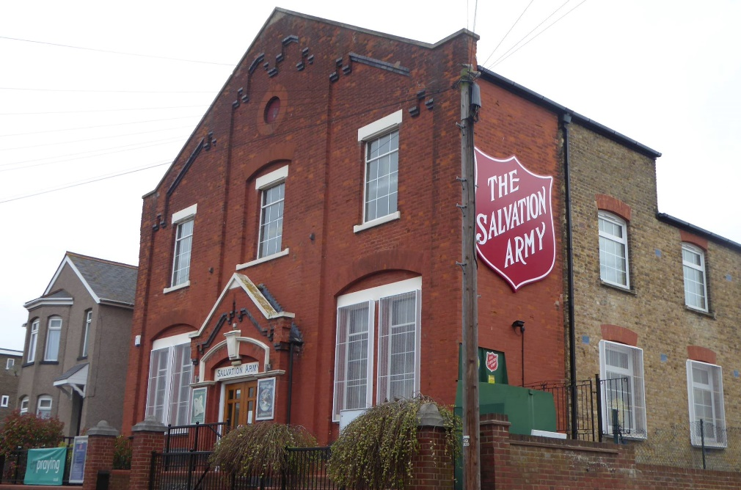

Our Mission
As disciples of Jesus Christ, Ramsgate Salvation Army exists to save souls, grow Saints, and serve suffering humanity.

Our Vision
As disciples of Jesus Christ, we will be a spirit-filled, radical, growing movement, with a burning desire to lead people to Jesus Christ, actively serve the community, and fight for social justice.
Major John has been on holiday….this is the best Carl can do!
What car did the wise men drive to see Jesus?
Honda Accord. The Bible says the wise men all came in one accord.
Who was the most business-savvy woman in the Bible?
Pharaoh’s daughter, who went down to the bank of the Nile and pulled out a little prophet.
What kind of person was Boaz before he got married?
Ruthless!
Where is the first tennis match mentioned in the Bible?
When Joseph served in Pharaoh’s court.
Who was the greatest comedian in the Bible?
Samson. He brought the house down.
Which servant of God was the worst lawbreaker in the Bible?
Moses. He broke all 10 commandments at once.
At what time of day was Adam created?
A little before Eve.
Why did Samson try to avoid arguing with Delilah?
He didn’t want to split hairs.
Which Bible character had no parents?
Joshua, son of Nun.

Pray for this important outreach and service to our community

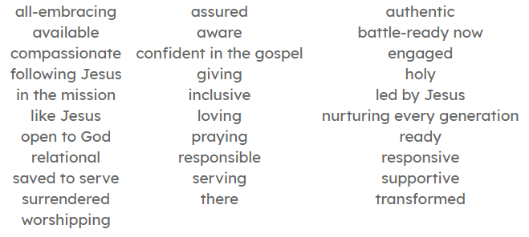
The Salvation Army. 167 High Street Ramsgate Kent CT11 9TT
Corps Leaders Carl Whitewood 07900497326 Heather Whitewood 07747 004950
Carl.whitewood@salvationarmy.org.uk Heatherwhitewood@salvationarmy.org.uk
www.salvationarmy.org.uk/ramsgate

