Ramsgate Salvation Army
Sunday 11th September 2022
A warm welcome as we gather as the family of God today,
especially if you are not normally with us on a Sunday.
May we all feel the welcome of God and each other.

We meet at The Salvation Army Hall Sunday 10.30 am.
Also Sunday worship is livestreamed on
You can find a link on the Ramsgate Salvation Army Web page
www.salvationarmy.org.uk/ramsgate

The Salvation Army. 167 High Street Ramsgate Kent CT11 9TT
Corps Leaders Carl Whitewood 07900497326 Heather Whitewood 07747 004950
Carl.whitewood@salvationarmy.org.uk Heather.whitewood@salvationarmy.org.uk
www.salvationarmy.org.uk/ramsgate
What’s happening at Ramsgate Salvation Army?

Sunday 11th September 10.30 am Sunday Worship –
11 am Sunday School
Monday to Friday (6.30am-9am) Breakfast Drop-in
Monday (9.30 am – 11.30 am) Little Fishes (Parent & Toddler group)
Monday (1pm) Start of ACES course
Tuesday (9am to 11am) Food Parcel Preparation
Tuesday (11 noon) Prayers followed by Light Lunch
Tuesday (13.00 pm) Bible Study at hall
Tuesday (7.00 pm) Corps Council Meeting
Wednesday (10 am) Friendship Club and Lunch Club
Wednesday (7pm) Songster and Band Practice
Thursday Forward Trust at hall (9-5).
Friday (10am - 12 noon) Food Bank
War Cry Sales
Friday (6.00pm) KIDS Club
Saturday (11am to 1.00pm) Ukrainian Hub
Sunday 18th September 10.30 am Sunday Worship
Funeral Service will be screened from Salvation Army Hall

Advance notice –CHANGES reflecting the time of national mourning
Sunday 25th September BACK TO CHURCH SUNDAY followed by buffet
Monday 26th September – Start of Pastoral Carers Course - 1 pm
Monday 26th September - YP workers meeting including S&S 1 - 7pm
Sunday 10th October - Harvest Celebration followed by harvest meal
Monday 10th October – Safeguarding Adults Training (one evening) - 7pm

MINI Market and Tabletop Sale Saturday 24th September 10 to 1pm

The chamber concert will be postponed. Another date has yet to be chosen.
Flowers for this week – Douglas and Pauline
Birthdays
Pauline Mackinney Sunday 11th September
Georgina James Monday 12 September

Prayers
We give thanks for Isobel’s return home – and pray for her continued healing Continue to pray for Barry Davies and for Ivor, (Tracy’s dad and Isaiah’s grandad)
Continued prayers for Josette and Joyce Hill and also for Angela’s sister Teresa undergoing cancer treatment.
For Alistair, a dear friend of Nicole, who died this week.
For Peter Ford admitted to hospital Saturday morning

Financial support for Ramsgate Corps
We have produced a simple new leaflet summarising how members, friends and supporting members of the public can help our work.
Two new ways to give are –
On our just giving page – which can be found using the QR codes or https://www.justgiving.com/fundraising/tsa-community-support-000444
Or google search “Just giving Ramsgate Salvation Army local community support.
Secondly we have card readers so you can donate using your bank card or phone app.
Billions of people now follow Christ's teaching and find in Him the guiding light for their lives. I am one of them, because Christ example helps me see the value of doing small things with great love.
Elizabeth II 2016

For me, the teachings of Christ on my own personal accountability before God provide a framework in which I try to lead my life. I, like so many of you, have drawn great comfort in difficult times from Christ's words and example.
Elizabeth II 2000

He knew rejection, hardship and persecution, and yet it is in Jesus Christ, generous love, an example which is inspired me through good times and bad.
Elizabeth II 2015

Christ not only revealed to us the truth in his teachings. He lived by what he believed and gives me the strength to try to do the same. And finally on the cross, he showed the supreme example of physical and moral courage.
Elizabeth II 1981

For me, the life of Jesus Christ, the Prince of Peace, is an inspiration and anchor in my life. Our model of reconciliation and forgiveness. He stretched out his hands in love, acceptance and healing. Christ's example has taught me to seek to respect and value all people, of whatever faith or none.
Elizabeth II 2014
Most Rev Justin Welby, Archbishop of Canterbury said “It is with profound sadness that I join the nation, the Commonwealth and the world in mourning the death of Her Late Majesty The Queen. My prayers are with The King and the Royal Family. May God draw near them and comfort them in the days, weeks and months ahead.

“As we grieve together, we know that, in losing our beloved Queen, we have lost the person whose steadfast loyalty, service and humility has helped us make sense of who we are through decades of extraordinary change in our world, nation and society”.

Most Rev Stephen Cottrell, Archbishop of York said: “In Her Majesty’s first Christmas broadcast, ahead of her Coronation she asked the nation, whatever their religion, to pray that God would give her wisdom and strength to carry out the solemn promise she would be making and to faithfully serve God and us all the days of her life.

“That is most definitely a prayer that has been answered. Her service to our nation and Commonwealth has been exemplified by her devotion to her duty, which has always been offered with joy. Underpinning this has been her deep faith in God and in her we have witnessed God’s faithfulness at work”.

This is the time when we must remember that God sent his only Son to serve, not to be served. He restored love and service to the centre of our lives in the person of Jesus Christ.
Elizabeth II 2012
Mark Green* asks “What do you think of the Queen?’
The reality is that the Queen is a woman with a deep faith centred on the sacrifice of Christ, the example of Christ, the teaching of Christ and the empowering of Christ. Whilst national media has often done little more than acknowledge her faith and moved swiftly on, she herself sees it as central to her life. We’ve seen this again and again in her Christmas addresses, which, unlike most of her other speeches, she writes herself.
There, she describes Christ as ‘the bedrock of my faith’, ‘my inner light’, ‘Saviour’, ‘the supreme example of physical and moral courage’, ‘compelling example’, ‘anchor’. For her, it is ‘in the person of Jesus Christ’ that God ‘restored love and service to the centre of our lives.’
Indeed, quite remarkably, these short ‘epistles to the nations’ reveal how her concern for peace, her summons to neighbour love and self-sacrifice for others, her yearning for peace and reconciliation are all tied to the biblical revelation in Christ.
Beyond that, even a cursory look at what the Bible says about godly monarchs shines a positive light on the Queen’s character. In Deuteronomy 17:18-20, for example, we read the call ‘to revere the Lord his God and follow carefully all the words of this law and these decrees’ – something the Queen has sought to do.
Similarly, she has clearly not considered herself better than her fellow ‘Israelites’ (vs 20). There is not a smidgen of entitlement in the Queen’s behaviour. Indeed, when it came to Prince Philip’s funeral, it would never have occurred to her to set aside the lockdown rules, even though the Government invited her to. The comparison with a bevy of international leaders is telling. Similarly, Hezekiah’s qualities (2 Kings 18:5-6) – the king like no other king of Judah before or since – gleam in Elizabeth II.
Praise God indeed that one of the most famous women in the world is such a glorious example of a whole-life disciple of Christ in public life.
*Mark Greene is Mission Champion at LICC, author of The Queen’s Way (2022), and, with Catherine Butcher, The Servant Queen and The King she Serves (2016). Find out more about LICC and get the essays at licc.org.uk.
Statement following the death of Her Majesty Queen Elizabeth II
8 September 2022
Commissioner Anthony Cotterill, Territorial Commander for The Salvation Army in the United Kingdom and Ireland said:
“We share the sorrow of the nation at the announcement of the death of Her Majesty The Queen Elizabeth II. It brings to an end a reign lasting more than 70 years. The Queen has remained steadfast in her Christian faith throughout the tremendous challenges and enormous changes the country has come through, in that time.
“Our sincerest condolences and prayers go out to The Queen’s children and grandchildren, and all of the Royal Family, at this extremely difficult time.
“As head of the Royal Family, The Queen has been an inspiration to us all and we give thanks for her long reign and her outstanding service to country and Commonwealth. We especially remember with gratitude and affection the occasions when she demonstrated her support for the frontline work of The Salvation Army.
“Throughout her reign the Queen was a keen supporter of The Salvation Army and she visited our services all over the world. She graced us with her presence at our centenary celebrations in 1965 at the Royal Albert Hall, the opening of Booth House in 1968, and appeared on the cover of Salvation Army publications many times. She regularly visited our centres and met the people we look after, including those battling drug addictions and homelessness. She opened many of our facilities, including our home for women in 1980 and numerous others around the country, always taking time to meet and talk with individuals. Most recently, The Queen graciously welcomed my wife and I to Windsor Castle to thank The Salvation Army, other faith groups and charities for work during the pandemic. It was an honour to meet her and members of the Royal Family.
“I know that Salvationists throughout the United Kingdom, and beyond, will give thanks to God for her long life of service, devotion to God and people and will continue to pray for the Royal family.”
Luke 10:25-37

Just then a lawyer stood up to test Jesus. 'Teacher,' he said, 'what must I do to inherit eternal life?' He said to him, 'What is written in the law? What do you read there?'
He answered, 'You shall love the Lord your God with all your heart, and with all your soul, and with all your strength, and with all your mind; and your neighbour as yourself.' And he said to him, 'You have given the right answer; do this, and you will live.'
But wanting to justify himself, he asked Jesus, 'And who is my neighbour?'
For me, as a Christian, one of the most important of these teachings is contained in the parable of the Good Samaritan, when Jesus answers the question, 'Who is my neighbour?' It is a timeless story of a victim of a mugging who was ignored by his own countrymen but helped by a foreigner – and a despised foreigner at that. The implication drawn by Jesus is clear. Everyone is our neighbour, no matter what race, creed or colour. The need to look after a fellow human being is far more important than any cultural or religious differences.
Elizabeth II 2004
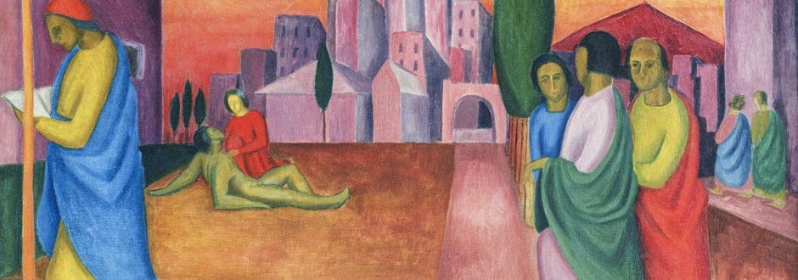

Statement by the Archbishop of Canterbury on the Death of Her Majesty The Queen
It is with profound sadness that I join the nation, the Commonwealth and the world in mourning the death of Her Late Majesty The Queen. My prayers are with The King and the Royal Family. May God draw near them and comfort them in the days, weeks and months ahead.
As we grieve together, we know that, in losing our beloved Queen, we have lost the person whose steadfast loyalty, service and humility has helped us make sense of who we are through decades of extraordinary change in our world, nation and society.
As deep as our grief runs, even deeper is our gratitude for Her Late Majesty’s extraordinary dedication to the United Kingdom, her Realms and the Commonwealth. Through times of war and hardship, through seasons of upheaval and change, and through moments of joy and celebration, we have been sustained by Her Late Majesty’s faith in what and who we are called to be.
In the darkest days of the Coronavirus pandemic, The Late Queen spoke powerfully of the light that no darkness can overcome. As she had done before, she reminded us of a deep truth about ourselves – we are a people of hope who care for one another. Even as The Late Queen mourned the loss of her beloved husband, Prince Philip, we saw once again evidence of her courage, resilience and instinct for putting the needs of others first – all signs of a deeply rooted Christian faith.
As we sustain one another in the face of this challenge, our shared grieving will also be a work of shared reimagining. I pray that we commence this journey with a sense of Her Late Majesty’s faith and confidence in the future.
As a faithful Christian disciple, and also Supreme Governor of the Church of England, she lived out her faith every day of her life. Her trust in God and profound love for God was foundational in how she led her life – hour by hour, day by day.

In The Late Queen’s life, we saw what it means to receive the gift of life we have been given by God and – through patient, humble, selfless service – share it as a gift to others.
Her Late Majesty found great joy and fulfilment in the service of her people and her God, “whose service is perfect freedom” (BCP). For giving her whole life to us, and allowing her life of service to be an instrument of God’s peace among us, we owe her a debt of gratitude beyond measure.
The Late Queen leaves behind a truly extraordinary legacy: one that is found in almost every corner of our national life, as well as the lives of so many nations around the world, and especially in the Commonwealth.
It was my great privilege to meet Her Late Majesty on many occasions. Her clarity of thinking, capacity for careful listening, inquiring mind, humour, remarkable memory and extraordinary kindness invariably left me conscious of the blessing that she has been to us all.
In my prayers at this time I also give thanks for the marriage of The Late Queen and His Late Royal Highness Prince Philip. Theirs was an inspirational example of Christian marriage – rooted in friendship, nourished by shared faith, and turned outwards in service to others.
May Her Late Majesty Queen Elizabeth II rest in peace and rise in glory.

The Most Reverend and Right Honourable Justin Welby

Archbishop of Canterbury
The National Anthem
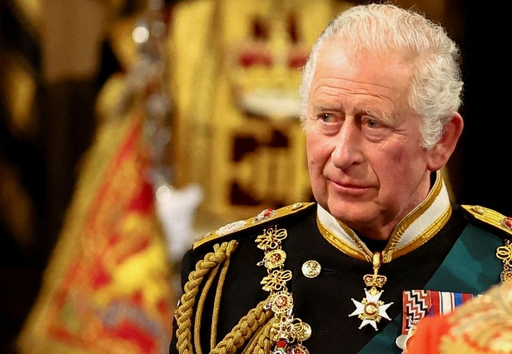
God save our gracious King!
Long live our noble King!
God save the King!
Send him victorious,
Happy and glorious,
Long to reign over us,
God save the King.

Thy choicest gifts in store
On him be pleased to pour,
Long may he reign.
May he defend our laws,
And ever give us cause,
To sing with heart and voice,
God save the King.

I know just how much I rely on my faith to guide me through the good times and the bad. Each day is a new beginning. I know that the only way to live my life is to try to do what is right, to take the long view, to give of my best in all that the day brings, and to put my trust in God!
Elizabeth II 2002

