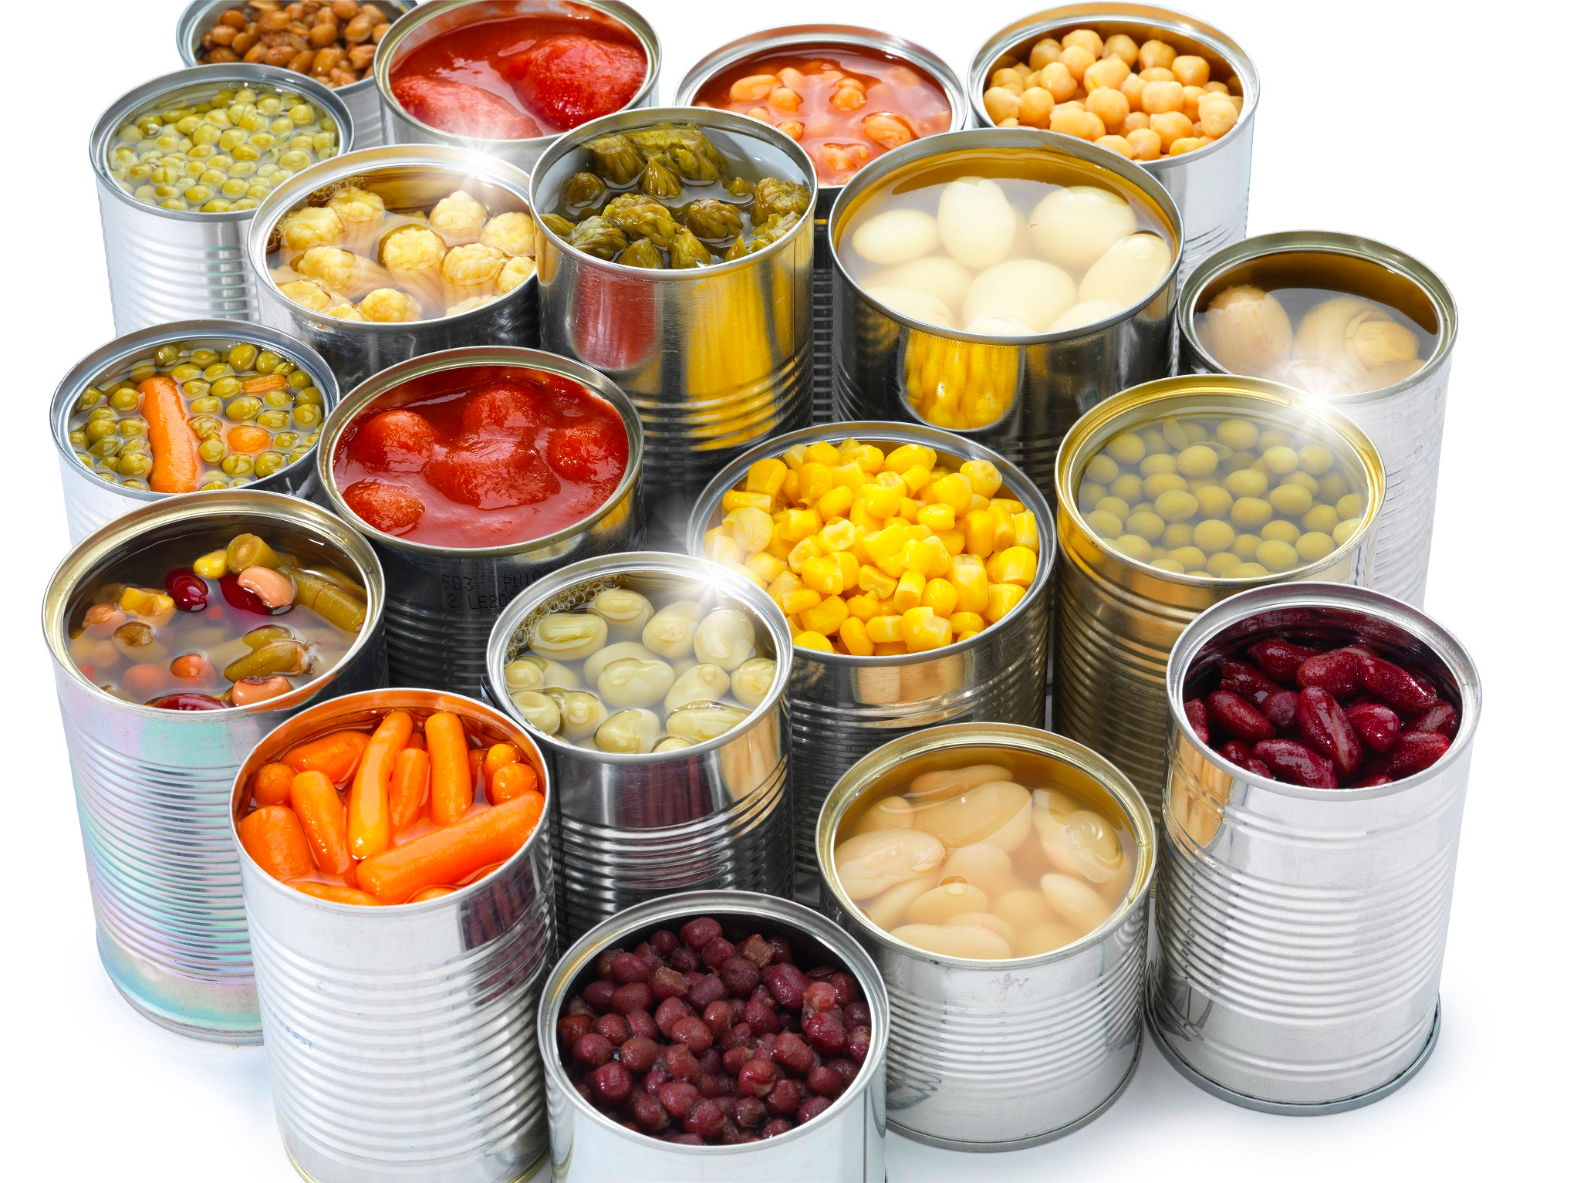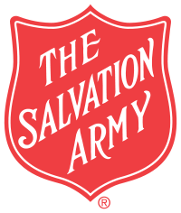

**Every week we help local people and families who are in crisis.**

***FOOD BANK APPEAL***

**UHT Milk**

**Tinned Meals**

**Pasta Sauce**

**Tuna/Sardines/Salmon**

**Chick peas/kidney beans**

**Micro noodles/pasta/rice**

**Jam, peanut butter, spread**

**Tinned potatoes, dry rice, packet mash**

**Tinned fruit/Rice Pudding/Custard**

**Ham/Corn Beef/Luncheon Meat**

**Nappies/Baby Wipes**

**Shampoo/Shower Gel**

**Toothpaste/ toothbrushes**

**Soap/Deodorant**

**Empty bags for Life/sturdy shopping bags**

Keighley Salvation Army

Registered Charity No. 214779