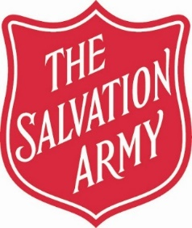

CHRISTMAS DAY LUNCH

25TH DECEMBER

12.30 PM – LUNCH

*FOR THOSE WHO WOULD BE ALONE OR IN NEED*



Followed with

2.00 PM – CAROL SERVICE

**Application Forms for our Christmas Day Meal can be obtained from:-**

**The Salvation Army Chalk Farm Corps,**

**10-16 Haverstock Hill, London, NW3 2BL**

**Office Tel: 020 7485 1605 E-mail:** [**chalk.farm.corps@salvationarmy.org.uk**](mailto:chalk.farm.corps@salvationarmy.org.uk)

**OR download a form from our Web Page:** https://www.salvationarmy.org.uk/chalk-farm

**A Christian Church & Registered Charity No.214779**