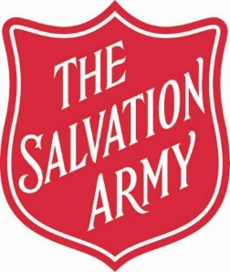

PLEASE SUPPORT OUR WORK

Scan the QR code to donate:

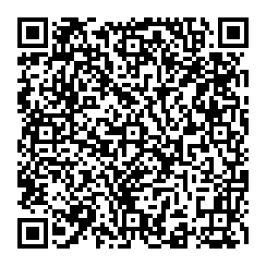 

Just Giving Page Text Giving

[www.justgiving.com/fundraising/thesalvationarmychristmas-2024-352](http://www.justgiving.com/fundraising/thesalvationarmychristmas-2024-352)

**To donate between £1 and £20**

*Thank Yo**u!*

**Text CHALKFARM 5 to donate £5**

***Text will cost the donation amount***

***plus one standard network rate message****.*

WE ALSO TAKE **BANK CARD** / GOOGLEPAY / APPLEPAY

ON OUR CARD READER MACHINE

**CASH** OR **CHEQUE** DONATIONS TO BE MADE PAYABLE TO:

***‘THE SALVATION ARMY’***

The Salvation Army Chalk Farm Corps,

10-16 Haverstock Hill, Camden Town, London, NW3 2B. Office: 020 7485 1605

E-mail: chalk.farm.corps@salvationarmy.org.uk

Web www.salvationarmy.org.uk/chalk-farm

Facebook: <https://en-gb.facebook.com/ChalkFarmSalvationArmy/>

Registered Charity No. 214779